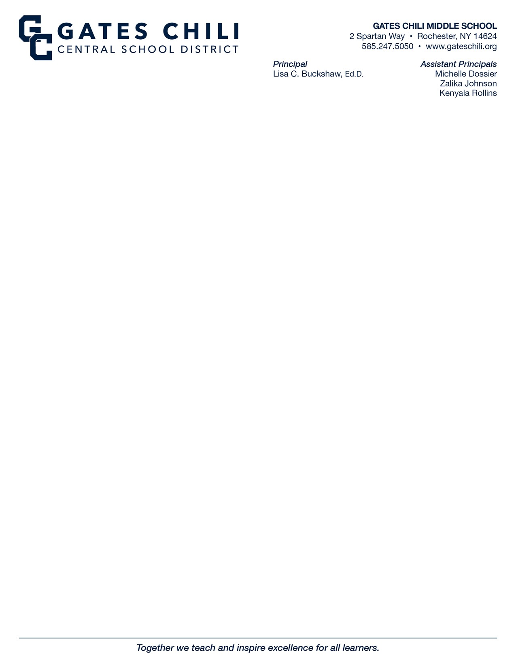

### September 2023

**To:** 8th Grade Students and Parent(s)/Guardian(s)

**From:** Ms. Rollins and Mrs. Newman

**Re:** 8th Grade Trip: Registration Packet Friday, June 7, 2024

We are excited to be able to take the eighth-grade students on a full day trip to Niagara Falls (the American side).

This registration packet has been prepared to assist you in your decision to participate in our end of year 8th grade trip. The trip is open to all eighth-grade students who have exhibited appropriate behavior and scholastic effort during the school year. To encourage students to maintain good academic and behavioral standing as defined in our District Code and Character, students must meet eligibility requirements to attend this event. **If misbehavior or academic failure has been an ongoing issue with any student, it will be decided upon (later this year) by an appeals committee as to whether that student will be allowed to attend.** If it is determined at a later date that a student is not able to attend due to misbehavior or lack of scholastic effort, **any payments made towards the trip will be forfeited**. Students must meet the eligibility requirements for our end of the year celebration for the 8th grade trip on June 7th and the farewell dance on June 21st. Please read this packet carefully and contact Ms. Rollins or Mrs. Newman at 247-5050 ext. 31301 if you desire more information or clarification.

### Some important details to note:

* The total cost of this trip is **$195.00**.
* **A $45 deposit (of which $35 is non-refundable)** is due on or before **December 1, 2023 (No Exceptions or late registration will be allowed)** along with the following:

### Registration/Medical Form/Permission Slip

* + **Behavior Contract**
  + **First Choice Educational Registration Sheets**
  + **First Choice Educational Insurance Form (FOR INSURANCE: Checks must be made out to: First Choice Educational Tours AND returned with the registration paperwork)**

As you may know, some of our eighth graders have already paid for part or all of their trip by participating in our school fundraisers. Any money raised from students who have earned more than the total cost of the trip will remain with PTO for general school expenditures.

**Preliminary Itinerary: Gates Chili Middle School 8th Grade Niagara Falls Class Trip: June 7, 2024**

**6:45 AM Meet at school**; BRING BAG LUNCH FROM HOME; Proceed to assigned chaperone table in the cafeteria.

**7:15 AM** Departure from Gates Chili Middle School- prompt departure via chartered motor coaches.

**9:00 AM** Arrive at **Niagara Falls**

#### *The following activities are scheduled for the day.*

* **Bag lunch for ALL** from home eaten at Fort Niagara State Park in an outside picnic area, weather permitting
* **Cave of the Winds** <https://www.niagarafallslive.com/cave_of_the_winds.htm>

### Maid of the Mist

<https://www.niagarafallslive.com/niagara_falls_maid_of_the_mist.htm>

* **Niagara Power Vista**

The group will visit and rotate through all six stations of their all innovative and interactive exhibits <http://nypa.gov/communities/visitors-centers/niagara-power-vista>

**4:00 PM** Dinner- DJ Dance Party at Banchetti’s Banquet Center [http://www.banchettibyrizzos.com](http://www.banchettibyrizzos.com/)

* Dinner and dance for all
* Menu: TBD

**7:00 PM** Load Buses for return trip home.

**9:00 PM** Estimated arrival back to Gates Chili Middle School bus loop.

This trip includes: Motor coach transportation, 8th grade trip T-shirt, admission to all activities mentioned above, dinner with private DJ/Dance, and services of two 1st Choice Educational Tour Guides during the trip.

**Gates Chili MS staff members are chaperoning this trip with one adult for every ten students**.

**Cost: $195.00 per student**

**Payment Schedule: #1) $45 deposit (of which $35 is non-refundable) due with Registration (Payment & registration forms required to register).**

**Registration deadline: December 1, 2023 (No Exceptions)**

**#2) Second payment $50 due January 5, 2024**

**#3) Third payment $50 due February 16, 2024**

**#4) FINAL PAYMENT $50 due March 22, 2024**

***Please note: You must make all payments by the due date in order for your student to remain registered for this trip.***

# All trip checks made payable to:

**“Gates Chili MS PTO”**

**Parent/Legal Guardian Permission/Medical Form**



As parent/legal guardian of , I give permission for him/her to participate in a school sponsored field trip as described in the letter from the teacher. I understand all school policies, regulations and rules will be in effect and apply to my student for the duration of the trip. If my student violates any rule or refuses to follow directions given by an adult, I understand consequences may be assigned.

**In case of emergency** I can be reached at . If I cannot be reached I give permission to contact (name and number) . I understand every effort will be made to contact me, but if the school is unable to reach me, I give the school/supervising staff member permission to seek medical help for my student. I agree to release and hold blameless the Gates Chili School District and district personnel of any financial burden in the event of an injury or theft.

**In the event a medical emergency occurs**, I’ve provided the following information; Name and number of family doctor: List of current medical conditions, if any:

List of current medications, if any: (If your student needs to take mediations while on the trip you need to contact the school nurse to make arrangements.)

List of allergies, food restrictions, physical limitations and/or phobias, if any:

Medical Insurance Company and policy number (optional): Other comments or information that should be known:

**REFUND POLICY**: All payments are nonrefundable, and parent agrees to no refund even if the school cancels the student for academic or behavioral reasons before or during the trip. No refunds for invalid, incomplete or missing School Permission Forms.

**DAMAGE**: Parent agrees to accept responsibility for the actions of the above named student with regard to any damages incurred at any point during the trip, either to property, self, or to another individual, and further agrees to make restitution in full for any and all such damages within seven (7) days of the return of this trip.

|  |  |  |
| --- | --- | --- |
|  | **Please indicate the T-shirt size your student will need.** |  |
| **Note: T-shirts are ADULT SIZE ONLY!**  **Extra Small Small Medium Large**  **X-Large 2X-Large 3X-Large** | | |

***Parent whose signature appears below acknowledges and agrees to all policies set forth.***

Parent or Guardian Name:

Parent or Guardian Signature:

Date:

## BEHAVIOR CONTRACT FOR NIAGARA FALLS 2024

✗ I agree to be in assigned areas, at assigned times, as asked.

✗ I agree to be a group member and participate in a cooperative manner.

✗ I agree to always have a partner and not travel solo.

✗ I agree to carry no medication or take any medication other than that dispensed by the designated teacher (unless arrangements have been made by the school nurse, chaperone, and parent/guardian).

✗ I agree to dress and conduct myself with dignity as a representative of my school.

✗ I agree to take my concerns to the designated adult supervisors.

✗ I agree to follow all school rules outlined in the Code of Conduct during this trip.

✗ I agree to follow all district expectations relative to health and safety.

✗ I agree to use headphones for all musical devices and will only use musical devices while on the bus.

✗ I agree to bring no glass containers on the trip and only bring beverage containers that have a screw top so they can be closed.

**Students will be supervised in a ratio of approximately 10 students per one adult.**

### I understand the above expectations and will fully comply with them.

#### *Student First Name (Print) Student Last Name (Print)*

#### *Student Signature Date*

**I have reviewed this agreement with my Middle School student.**

#### *Parent Signature Date*

### GATES CHILI MIDDLE SCHOOL – 8th GRADE

**TRIP REGISTRATION FORM FOR TRAVELING STUDENT NIAGARA FALLS, NY**

**JUNE 7, 2024**

**PRINT STUDENT’S LEGAL NAME:**

Page 1 of 2

**ADDRESS:**

**CITY:**

**STATE: ZIP:**

**HOME PHONE:**

**PARENT’S CELL PHONE:**

**PARENT’S EMAIL:**

**STUDENT’S DATE OF BIRTH:**

**GENDER:**

**PRINT PARENT’S NAME:**

**VEGETARIAN: YES**

**NO**

**DIETARY RESTRICTIONS:**

**1st Choice Educational Tours Policies & Procedures**

**RATE INFORMATION:** All trips are priced based on your estimated number of participants. If the group size falls below the guaranteed number, prices will be adjusted accordingly. Prices reflect current fuel prices. The motor coach company, train and/or airline company reserves the right to add a fuel surcharge to the final price if over the applicable service date fuel prices have increased significantly from the date of contract agreement. Initials

**PAYMENT TERMS:** A booking fee is required per person and calculated into the deposit to ensure space on a contracted trip. One day trip - $25.00 / Two day trip - $50.00 / Three day trip & over - $75.00. The booking fee is non-refundable and non-transferable. Final payment is due at 1st Choice Educational Tours 60 days prior to the trip departure date. If a trip is booked within 60 days of the departure date, one lump sum payment will be required upon booking. Initials

Page 2 of 2

**GATES CHILI MIDDLE SCHOOL – 8th GRADE**

**REFUNDS:** The $25.00 booking fee is non-refundable and non-transferable. A person unable to attend the trip is encouraged to find a school approved replacement to avoid the loss of monies paid. Participants who cancel and do not arrange for a replacement will be sent a refund after the return of the trip equal to the value of the refundable unused meals and admissions. Transportation, lodging, prepaid admissions, and all administrative booking fees are not refundable. Optional cancellation insurance is available and suggested. Initials

**RESPONSIBILITY:** 1st Choice Educational Tours, a division of First Choice Travel, Inc. acts as an agent for educational and travel related suppliers in all matters relevant to transportation, entertainment, attractions, sightseeing, and other tour-related features. As an agent, 1st Choice Educational Tours has no control over the personnel, facilities or equipment of such suppliers and accepts no responsibility or liability for loss, damage, personal injury, accident, inconvenience, delay or irregularity, regardless of the cause, related to or during a trip. 1st Choice Educational Tours retains the right to substitute any tour component with another of comparable or better value. 1st Choice Educational Tours recommends cancellation insurance. Initials

Any check returned by the bank for any reason will result in a $20.00 service charge. Initials

Your signature and initials indicate that you have read, fully understand and are in agreement with the terms and conditions.

**PARENT’S SIGNATURE:**

**DATE:**

**IMPORTANT:**

**MAKE SURE TO INITIAL IN FIVE PLACES THEN SIGN. INCOMPLETE FORMS WILL NOT BE ACCEPTABLE.**

**NO STUDENT WILL BE REGISTERED FOR A TRIP WITHOUT THE COMPLETED AND SIGNED REGISTRATION FORM.**

##### TRAVEL GUARD ELECTION FORM FOR TRAVELING STUDENT GATES CHILI MIDDLE SCHOOL – 8th GRADE

**NIAGARA FALLS, NY JUNE 7, 2024**

**MUST BE COMPLETED AND RETURNED**

First Choice Educational Tours is pleased to offer travel insurance protection from Travel Guard International.

Please refer to the provided coverage overview.

Unforeseen circumstances can arise and often do. Emergencies can occur before departure or while you are traveling. We highly recommend this travel insurance and urge you to give it careful consideration.

I have been offered Travel Guard protection for my trip and have chosen:

**OPTION #1 -** Purchase the insurance offered. A check in the amount of **$9.15** should be made payable to 1st Choice Educational Tours and paid at the time of deposit payment in order for the waiver of Pre- existing Medical Condition Exclusion to be included.

**OPTION #2** - Purchase the Optional Coverage – Cancel for any reason. The insurer will reimburse 50% of non-refundable expenses if you cancel your trip for any reason, **up to 48 hours prior** to your departure. This coverage can only be purchased at the time of deposit payment. If you are purchasing this coverage the check should be in the amount of **$12.08**. You do not have to pay for option #1 if you select this option.

**OPTION #3** - Decline to purchase the insurance option #1 or option #2 that is being offered. I fully understand that by declining to purchase travel insurance, 1st Choice Educational Tours cannot be held responsible for any expenses incurred by me that would have been covered by this travel insurance.

##### Please select one of the options above, complete the information below, sign and return to Gates Chili Middle School. No student will be registered for a trip without the completed and signed Travel Guard election form and registration form. If you wish to purchase the insurance, please send the check for the insurance to the school with your check for the deposit.

Parent’s Name Printed

Signature Date

Student’s Name

Street Address

City State Zip Code



**STUDENT TRAVEL**

**PROTECTION PLAN**

Travel Insurance & Global Assistance

926401

Confidence makes a great traveling companion.

**Because no matter how hard you try, there are some things you just can’t plan for.** Make sure you pack a Travel Guard Student Travel Protection Plan which provides valuable coverage, at an affordable price, and to help bring home amazing travel memories, not unexpected expenses due to travel mishaps.

## Travel Smart with Travel Guard.

You can be covered:

* if you incur medical expenses, for an unforeseen injury or sickness, during the course of your trip.
* if you have to return home early due to an unexpected emergency such as an illness or death in the family.
* if your luggage is lost or delayed, forcing you to purchase necessary essentials.
* if you need an emergency medical evacuation due to an accident or sudden illness.

##### To view a full listing of coverage benefits, please refer to the Policy of Insurance.

**Always there, 24/7.**

Virtually anywhere you travel, in the event of a medical emergency or unexpected travel problem, we are never more than a phone call away.

* 24-hour emergency assistance
* Passport or ticket replacement assistance
* Prescription replacement assistance
* And more!

**QUESTIONS?**

CALL TOLL-FREE:

## 1.877.254.8922

**THIS IS A BRIEF DESCRIPTION OF COVERAGE – LIMITATIONS APPLY**

**Coverage may not be available in all states. Coverage varies by state.** For complete coverage information and exclusions, please refer to the Policy of Insurance for your state of residency prior to purchase, by visiting [www.travelguard.com/policy/student](https://webservices.travelguard.com/Product/FileRetrieval.aspx?CountryCode=US&amp;StateCode=AL&amp;ProductCode=926401&amp;PlanCode=NW&amp;FileType=PROD_PLAN_GM).

## COVERAGE

**EXTRA COVERAGE**

**Pre-Existing Medical Condition Exclusion Waiver** (Policy must be purchased within 15 days of the Initial Trip Payment. Day one is the date the initial payment is received. If the policy is not purchased within 15 days of the Initial Trip Payment, then a 60-day look-back period applies. For residents of ID, MN and NY, the look-back period is 180-days.)

|  |  |
| --- | --- |
| **Per Person** | **Maximum Limit Up To** |
| **Trip Cancellation1** | 100% of Insured Trip Cost  (Maximum of $25,000) |
| **Trip Interruption1** | 150% of Insured Trip Cost  (Maximum of $37,500) |
| **Single Occupancy** | 100% of Insured Trip Cost  (Maximum of $25,000) |
| **Trip Delay** | $500  (Maximum of $100 per day, 12 HRS) |
| **Baggage Coverage** | $1,000 (Primary) |
| **Baggage Delay** | $100 (24 HRS) |
| **Travel Medical Expense/ Dental Expense** | $50,000 (Primary)  $500 |
| **Emergency Evacuation**  **and Repatriation of Remains** | $500,000 |
| **Ancillary Evacuation Benefits** *(including Baggage Return, Return Transportation and Bedside Visit)* | $2,500 |
| **Non-flight Accidental Death**  **& Dismemberment** | $30,000 |
| **Assistance Services2** *Travel Medical Assistance Worldwide Travel Assistance* | Included |

## OPTIONAL COVERAGE

**Cancel for Any Reason, up to 50% of Trip Cost3** (Must be purchased within 15 days of Initial Trip Payment.)

**Coverage available to U.S. residents of the U.S. states and District of Columbia only.** This plan provides insurance coverage that only applies during the covered trip. You may have coverage from other sources that provides you with similar benefits but may be subject to different restrictions depending upon your other coverages. You may wish to compare the terms and conditions of this policy with those of your existing life, health, home and automobile insurance policies, as well as any coverage which may be available to you through your credit card program(s). If you have any questions about your current coverage, call your insurer or insurance agent or broker. Coverage is offered by Travel Guard Group, Inc (Travel Guard). California lic. no.0B93606, 3300 Business Park Drive, Stevens Point, WI 54482, [www.travelguard.com.](http://www.travelguard.com/) CA DOI toll free number: 800-927-HELP. This is only a brief description of the coverage(s) available. The Policy will contain reductions, limitations, exclusions and termination provisions. Insurance

underwritten by National Union Fire Insurance Company of Pittsburgh, Pa., a

Pennsylvania insurance company, with its principal place of business at 1271

Expenses incurred from third-party vendors for assistance services not part of a filed insurance plan are the responsibility of the traveler.

1. Coverage only applicable to prepaid, non-refundable trip costs identified on the enrollment form and if the required plan cost has been paid.
2. Non-insurance services are provided by Travel Guard.
3. Cancel for Any Reason is available as a service to residents of NY.

Avenue of the Americas, 37th FL, New York, NY 10020-1304. It is currently authorized to transact business in all states and the District of Columbia. NAIC No. 19445. Coverage may not be available in all states. Your travel retailer may not be licensed to sell insurance, and cannot answer technical questions about the benefits, exclusions, and conditions of this insurance and cannot evaluate the adequacy of your existing insurance. The purchase of travel insurance is not required in order to purchase any other product or service from the travel retailer. Travel assistance services provided by Travel Guard.

926401 TG-13544-22 05/31/22